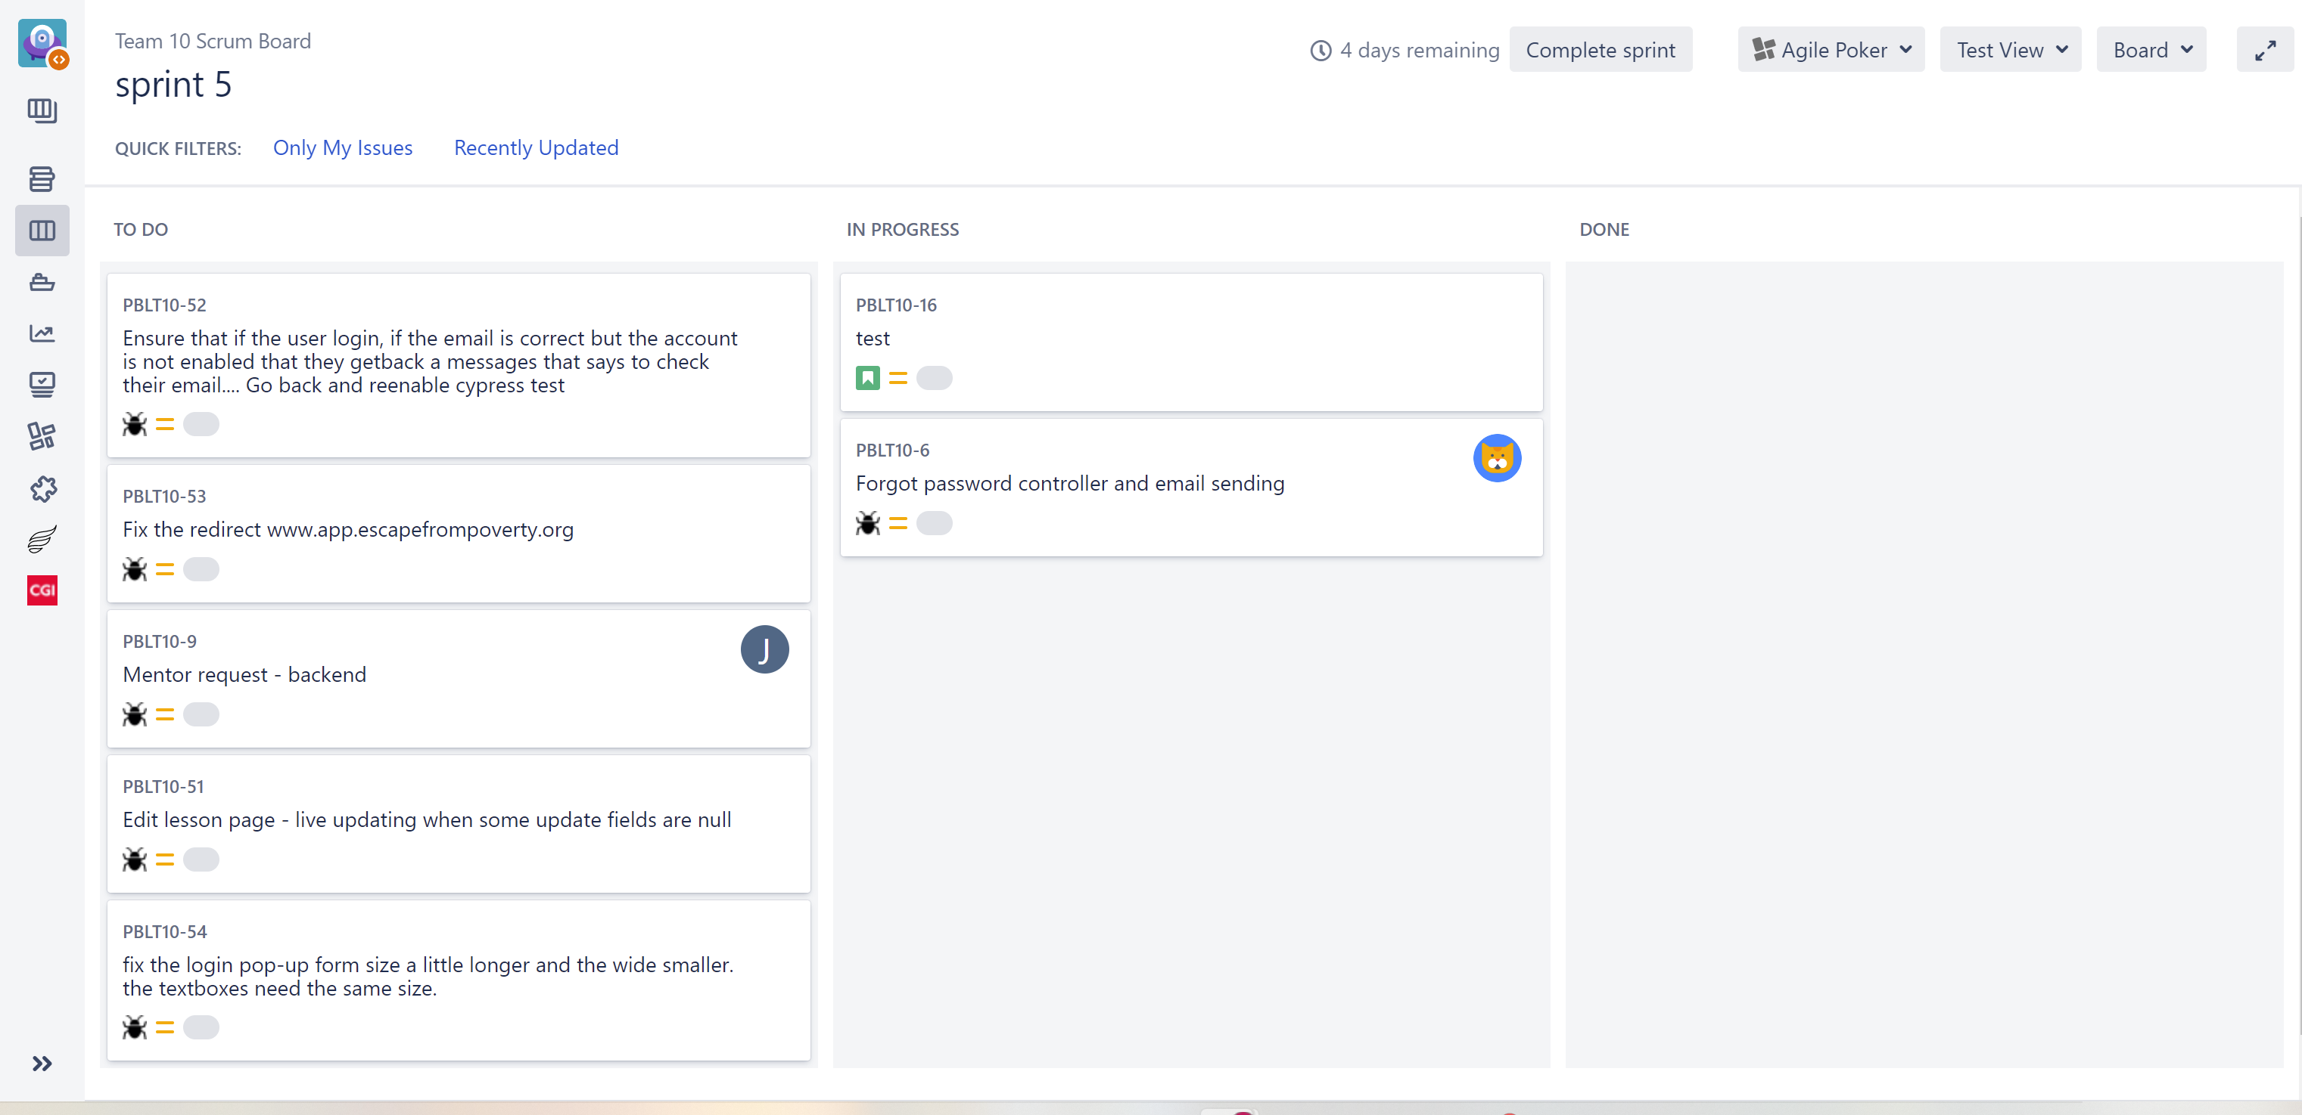
Group 10 Sprint Backlog 5 (April 18- April 25)
Priority | Sprint task | User story | Acceptance criteria | Assignees | Duration of task (hours)
1 | Test all the functions and features of the website.  Create bug tasks in JIRA | As a user. I want to see confirmation that my actions and input on the website were successful. | Write Cypress script for testing if the website functionality responds as planned.  Data entry in the role of website user. | Hien | 18
2 | Fix bugs | As developer I need to ensure there are no defects | Address and correct any errors found in task 1 | Chris/Carl | 24

